**Unique BST**

Legend



rootPtr

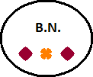

 



|  |
| --- |
| India2000 ... |
| India1990 ... |

...  
...  
...

**Secondary BST**

rootPtr



 



**Hash Table**

